WELCOME TO THE GONZALES DOLPHINS
2017 SUMMER SWIM TEAM!

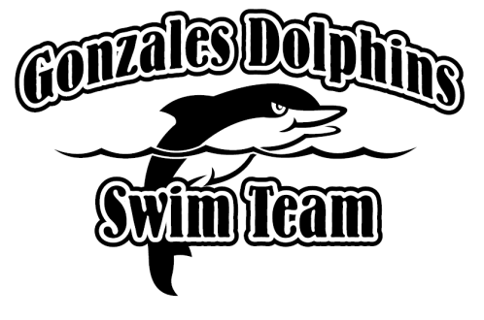

LOCATION: JAMBALAYA PARK POOL
1015 E CORNERVIEW ST.
GONZALES, LA 70737
PHONE #: (225) 647-9564 [POOL HOUSE]
WEBSITE: Jambalayaparkpool.com

OUR COACHES
HEAD COACHES: KELLEY FRUGÉ
Email: kelleyf@selaaquatics.com
ASSISTANTS: CAITLYN KERNAN
TAYLOR STEPHENS
MONIQUE THERIOT
LORELEI GAFFNEY

PRACTICE SCHEDULE (Age groups are set as of June 1, 2017)
Optional April Practices – Begins Monday, April 3
- 10 & Under: Monday & Wednesday from 6:00pm - 6:50pm
- 11 & Older: Monday & Wednesday, from 7:00pm - 7:50pm
After School Practices – Begins Monday, May 8
- 8 & Under: Monday & Wednesday, 6:00pm - 6:50pm
- 9-12's: Tuesday & Thursday, 6:00pm - 6:50pm
- 13 & Older: Mon - Thursday, 7:00pm - 7:50pm
Summer Schedule – Begins Tuesday, May 30
Morning Practice
- 13 & Older: Monday, Tuesday, & Wednesday from 7:00am - 7:50am
- 9-12's: Monday, Tuesday, & Wednesday from 8:00am - 8:50am
- 8 & Under: Monday, Tuesday, & Wednesday from 9:00am - 9:50am
Evening Practice
- 10 & Under: Monday & Wednesday from 7:00pm - 7:50pm
- 11 & Older: Tuesday & Friday from 7:00pm - 7:50pm

Once the Summer Schedule begins, Thursday mornings that fall on days without meets WILL be held at the usual times for all age groups. Friday evening practices may also be moved to Thursday evenings.
NOTE: Swimmers who attend the wrong practice will not have a coach designated to work with during those times.
MEET SCHEDULE (Please refer to the team website for full meet info!)
@ Magnolia Woods - Thursday, June 1st (4:00pm)
@ Bocage - Thursday, June 8th (4:00pm)
vs. Kenilworth - Thursday, June 15th (4:00pm)
vs. Tara - Thursday, June 22nd (4:00pm)

WHO ARE WE?
The City of Gonzales is proud to offer a summer swim team experience for children ages 4 through 18. As part of the Greater Baton Rouge Swim League, the Gonzales Dolphins participate in swim meets against swim clubs from across the Baton Rouge area. With roughly 150 members, this experience is excellent for children of all ages!

OUR WEBSITE (jambalayaparkpool.com)
This website is the center of our swim team! Once you register, please be sure you keep your Username and Password so you may have access to it for this season, as well as every future season you remain with the team. All the information in this pamphlet and more is found in the “Swim Team” tab of the site. Your account will keep record of your swimmer’s meet times and will show when your child is improving in their events. Most importantly, you will use it to submit swimmer entries and job sign-ups for every meet. More information about this will be given as June approaches.

*** Please visit the “Important Policies” section of the “Swim Team” tab for many team policies which could not be covered on this pamphlet. Reviewing these would go a long way to ensure swimmer safety and smooth practice/meet procedure.

PRACTICE GUIDE
Please be sure your child has a Team Suit before the first swim meet. These can be ordered through the team website under the “Team Suits” section of the “Swim Team” tab. Swimmers may wear any acceptable practice suit, so long as they are secure.

*** The website our suits come from may not have suits available for the smallest sizes. If that is the case, you are welcome to purchase any all-black or black & red suit at any local or online athletic/competitive swim shop!

Not Allowed – Not For Competitive Discouraged – One Strap, Low Price Preferred & Encouraged – One/Two Straps,
Swim (Nose/ear plugs accepted) Less Reliable, Easily Broken Durable, Reliable, And Secure
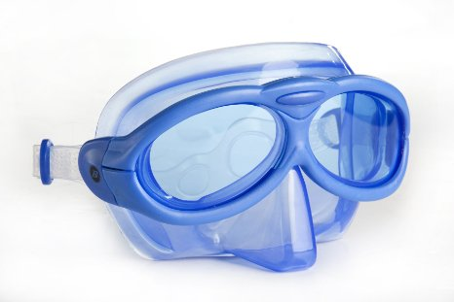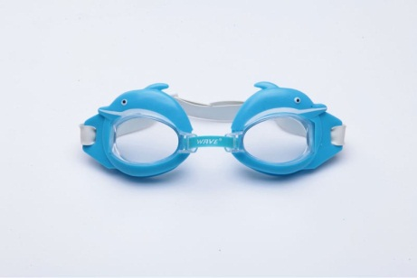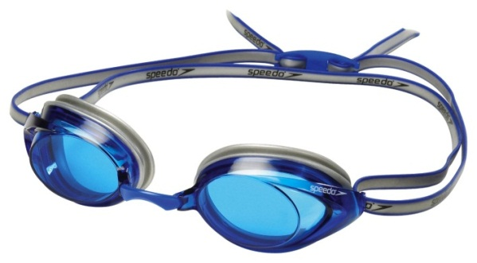

LET’S HAVE A FUN, SUCCESSFUL SUMMER
GEAUX DOLPHINS!

